Honorary prize for Dr. Ulrich Stiebel
The German Association for Electrical and Information Technology Trades (ZVEH) has awarded Dr. Ulrich Stiebel, co-owner of the STIEBEL ELTRON Group, the E-Markenpartner prize. ZVEH President Lothar Hellmann and ZVEH Vice President and Chairman of the ArGe Medien in the ZVEH Hans Auracher presented the award at a ceremony held.
"The corporate brand STIEBEL ELTRON of the honorary prize winner Dr. Ulrich Stiebel is a household name for all consumers in Germany. He himself has made a special contribution to the topics of renewable energies, visionary research and development and the promotion of education," said the ZVEH. Stiebel attaches great importance to the active support of its partners with training courses, sales support measures and services. "Despite the international success and the size of his company, Dr. Stiebel ensures that the company remains an independent and at the same time deeply human, personal family business," says ZVEH President Hellmann.
"The award ceremony is another gratifying event that our family and the company can celebrate this year - in addition to the historic events '125 years of Theodor Stiebel' and '95 years of Stiebel Eltron'," commented Dr. Ulrich Stiebel on the award. "It is also a great recognition for the quality of our products and services as well as our loyalty to the trade."

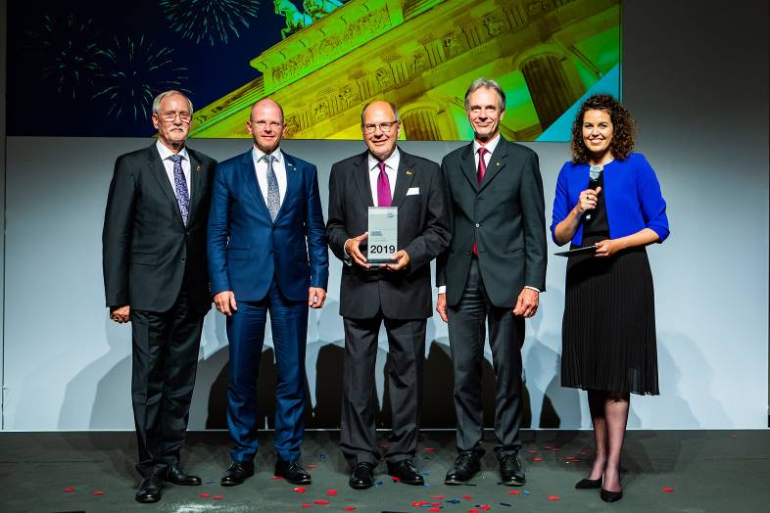
ZVEH President Lothar Hellmann, Frank Jahns (Managing Director of STIEBEL ELTRON-Vertriebsgesellschaft Deutschland), Dr. Ulrich Stiebel, ZVEH Vice President Hans Auracher and presenter Katie Gallus (from left).

