STIEBEL ELTRON is a "Superbrand"
Sixth award in a row for the Holzminden-based company
Stiebel Eltron was voted "Superbrand" for the sixth time in a row. Advertising manager Fátima Freitas and press officer Henning Schulz accepted the award at a ceremony in Berlin. "The renewed award is a great feedback for the brand, which we are very pleased about", explains Fátima Freitas. In addition to Stiebel Eltron, brands such as Deutsche Bank, Bitburger, Miele and Adidas also received awards. Medical doctor and comedian Dr. Eckart von Hirschhausen received this year's award for superbrand personality.
For over 25 years, the world's largest brand evaluation organization Superbrand, based in London, has been awarding prizes to the best and strongest brands in over 88 countries. Within the framework of the eighth procedure in Germany, the Superbrands Germany 2018/2019 have now been selected by the 23-member jury. In cooperation with international market research institutes, independent business experts nominate the outstanding product and corporate brands of a country - in Germany, 1,350 nominees made it onto the suggestion list. The expert jury, consisting of personalities from business, politics, the media and universities, selected the 100 best of these - including Stiebel Eltron - according to the same evaluation criteria that apply worldwide. The criteria are brand dominance, customer loyalty, goodwill, longevity and overall brand acceptance.

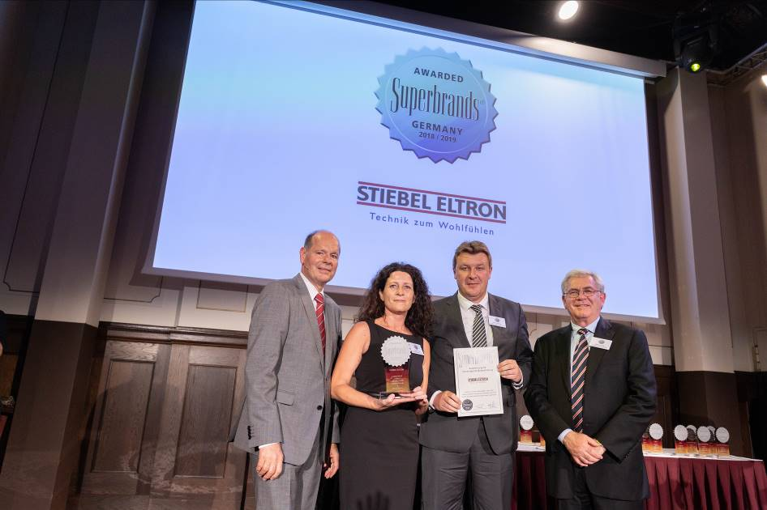
Advertising manager Fátima Freitas and press spokesman Henning Schulz (centre) are happy about the sixth Superbrand award in a row for Stiebel Eltron. Congratulations came from Norbert Lux, Managing Director Superbrands Germany (left) and Stephen Smith, Chairman Superbrands International.

